|  |  |
| --- | --- |
| **Assignment** | |
| **Course Code** | CSC401A |
| **Course Name** | Computational Intelligence |
| **Programme** | B.Tech |
| **Department** | CSE |
| **Faculty** | FET |

|  |  |
| --- | --- |
| **Name of the Student** | Satyajit Ghana |
| **Reg. No.** | 17ETCS002159 |
| **Semester/Year** | 07/2021 |
| **Course Leader(s)** | Mr. Sagar U |



|  |  |  |  |  |  |  |  |  |
| --- | --- | --- | --- | --- | --- | --- | --- | --- |
| Declaration Sheet | | | | | | | | |
| Student Name | Satyajit Ghana | | | | | | | |
| Reg. No | 17ETCS002159 | | | | | | | |
| Programme | B.Tech | | | | | Semester/Year | 07/2021 | |
| Course Code | CSC401A | | | | | | | |
| Course Title | Computational Intelligence | | | | | | | |
| Course Date |  | | to |  | | | | |
| Course Leader | Mr. Sagar U | | | | | | | |
| **Declaration**  The assignment submitted herewith is a result of my own investigations and that I have conformed to the guidelines against plagiarism as laid out in the Student Handbook. All sections of the text and results, which have been obtained from other sources, are fully referenced. I understand that cheating and plagiarism constitute a breach of University regulations and will be dealt with accordingly. | | | | | | | | |
| Signature of the Student | |  | | | | | Date |  |
| Submission date stamp  (by Examination & Assessment Section) | |  | | | | | | |
| Signature of the Course Leader and date | | | | | Signature of the Reviewer and date | | | |
|  | | | | |  | | | |

# Contents

Declaration Sheet ii

Contents iii

List of Figures iv

1 Question 1 5

1.1 A critical review of cognitive abilities of ANNs 5

1.2 The application areas in which ANNs have been successful in delivering human-like performance 5

1.3 Conclusion 5

2 Question 2 6

2.1 A model of generalized fuzzy decision system for project evaluation 6

2.2 Fuzzy sets with attributes 10

2.3 Dataset (test cases) generation 16

2.4 Fuzzy Logic System Creation 17

2.5 Evaluating Student Performance 20

2.6 Results 27

Bibliography 29

Appendix 30

# List of Figures

# Question 1

Solution to Question No. 1 Part A

## A critical review of cognitive abilities of ANNs

## The application areas in which ANNs have been successful in delivering human-like performance

## Conclusion

# Question 2

Solution to Question 1 Part B

## A model of generalized fuzzy decision system for project evaluation

Pandey et al. (2015) proposed a fuzzy logic based grading system for student projects using quality attributes, most of this assignment is inspired from their proposed solution.

But first, we build the whole pipeline of how the whole system would work,

Fuzzy logic is branch of logic specially designed for representing knowledge and human reasoning in such a way that it amenable to processing by a computer. Fuzziness pertains to uncertainty associated with a system i.e. the fact that nothing can be predicted with exact precision. Fuzziness is property of language. Its main source is the imprecision in defining and using symbol. A fuzzy set is a collection of distinct elements with a varying degree of relevance or inclusion. There are two commonly used ways of denoting fuzzy sets. **(Pandey et al, 2015)**

A fuzzy variable has a crisp value which takes on some number over a pre-defined domain (in fuzzy logic terms, called a universe). The crisp value is how we think of the variable using normal mathematics. For example, if my fuzzy variable was how much to tip someone, it’s universe would be 0 to 25% and it might take on a crisp value of 15%.

If $X$ is the Universe of discourse and $x$ is a particular element of $X$, then a fuzzy set $A$ defined on $X$ may be written as a collection of ordered pairs:

$$A=\left\{\left(x, μ_{A}(A)\right)\right\}, x∈X$$

Where each pair $\left(x, μ_{A}(A)\right)$ is called a singleton, where $x$ is followed by its membership function $μ_{A}(A)$,

Singleton can also be written as $μ_{A}(x)/x$ and fuzzy set $A$ can also be represented as.

$$A=\sum_{x_{i}}{\frac{x_{i}}{μ_{A}(x_{i})}}$$

Membership function also known as characteristic function can take value between 0 and 1 and indicates degree of membership. Since there are infinite numbers between 0 and 1, infinite degrees of membership are possible.

For this assignment, we need to create a generalized system for project evaluation, where students show their project with their project report, and power point presentation. Experts judge on different criteria, and assign an opinion as a linguistic term (excellent, very good, good, average or bad). Their opinion has to be combined for grading the project.

To solve this, first a set of project attributes are selected, and their possible linguistic terms are selected. A fuzzy decision set is formed which indicate expert opinion for each project attributes. Fuzzy set is then defined for each attribute. A fuzzy subset is formed for all linguistic terms. For example, presentation can be Excellent, Very Good, Good, Average, Fair or Bad. Similarly, Modularity can be High, Medium, Low, Very Low or Nil.

Following are the attributes and their linguistic terms used to denote the evaluation of a student project,

1. Documentation
   1. Excellent (E)
   2. Very Good (VG)
   3. Satisfying (S)
   4. Moderate (D)
   5. Limited (L)
   6. Bad (B)
2. Presentation
   1. Excellent (E)
   2. Very Good (VG)
   3. Good (G)
   4. Average (AV)
   5. Fair (F)
   6. Bad (B)
3. Security/Authentication
   1. Excellent (E)
   2. Very Good (VG)
   3. Good (G)
   4. Average (AV)
   5. Fair (F)
   6. Bad (B)
4. Functionality
   1. Excellent (E)
   2. Very Good (VG)
   3. Good (G)
   4. Average (AV)
   5. Fair (F)
   6. Bad (B)
5. Modularity
   1. Very High (VH)
   2. High (H)
   3. Medium (M)
   4. Low (L)
   5. Very Low (VL)
   6. Nil (N)
6. Design of User Interface
   1. Excellent (E)
   2. Very Good (VG)
   3. Good (G)
   4. Average (AV)
   5. Fair (F)
   6. Bad (B)

Now that these linguistic terms are fixed, we can assign a membership function to each of them, i.e. the fuzzy subset representation to them. Further we will proceed by creating a logic of how to aggregate these opinions into numeric values and then defuzzify the value to assign a final grade to the student like Ex, A+, A, B, B+, or C.

## Fuzzy sets with attributes

Following are the six attributes and considerable corresponding linguistic terms that are selected for project evaluation along with their fuzzy subsets:

1. Documentation
   1. Excellent (E): 1/1.0+2/0.8+3/0.6+4/0.4+5/0.2+6/0.0
   2. Very Good (VG): 1/0.8+2/1.0+3/0.8+4/0.6+5/0.4+6/0.2
   3. Satisfying (S): 1/0.6+2/0.8+3/1.0+4/0.8+5/0.6+6/0.4
   4. Moderate (D): 1/0.4+2/0.6+3/0.8+4/1.0+5/0.8+6/0.6
   5. Limited (L): 1/0.2+2/0.4+3/0.6+4/0.8+5/1.0+6/0.8
   6. Bad (B): 1/0.0+2/0.2+3/0.4+4/0.6+5/0.8+6/1.0

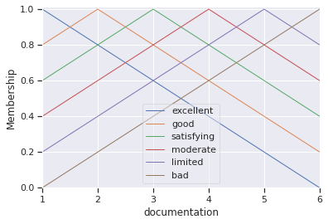

1. Presentation
   1. Excellent (E): 1/1.0+2/0.8+3/0.6+4/0.4+5/0.2+6/0.0
   2. Very Good (VG): 1/0.8+2/1.0+3/0.8+4/0.6+5/0.4+6/0.2
   3. Good (G): 1/0.6+2/0.8+3/1.0+4/0.8+5/0.6+6/0.4
   4. Average (AV): 1/0.4+2/0.6+3/0.8+4/1.0+5/0.8+6/0.6
   5. Fair (F): 1/0.2+2/0.4+3/0.6+4/0.8+5/1.0+6/0.8
   6. Bad (B): 1/0.0+2/0.2+3/0.4+4/0.6+5/0.8+6/1.0

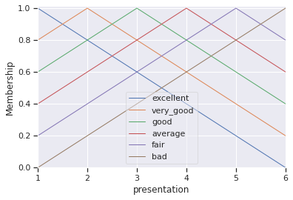

1. Security/Authentication
   1. Excellent (E): 1/1.0+2/0.8+3/0.6+4/0.4+5/0.2+6/0.0
   2. Very Good (VG): 1/0.8+2/1.0+3/0.8+4/0.6+5/0.4+6/0.2
   3. Good (G): 1/0.6+2/0.8+3/1.0+4/0.8+5/0.6+6/0.4
   4. Average (AV): 1/0.4+2/0.6+3/0.8+4/1.0+5/0.8+6/0.6
   5. Fair (F): 1/0.2+2/0.4+3/0.6+4/0.8+5/1.0+6/0.8
   6. Bad (B): 1/0.0+2/0.2+3/0.4+4/0.6+5/0.8+6/1.0

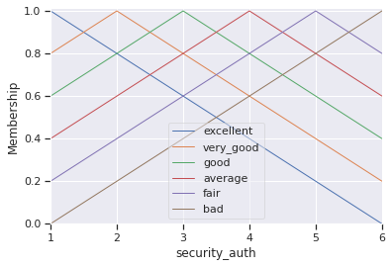

1. Functionality
   1. Excellent (E): 1/1.0+2/0.8+3/0.6+4/0.4+5/0.2+6/0.0
   2. Very Good (VG): 1/0.8+2/1.0+3/0.8+4/0.6+5/0.4+6/0.2
   3. Good (G): 1/0.6+2/0.8+3/1.0+4/0.8+5/0.6+6/0.4
   4. Average (AV): 1/0.4+2/0.6+3/0.8+4/1.0+5/0.8+6/0.6
   5. Fair (F): 1/0.2+2/0.4+3/0.6+4/0.8+5/1.0+6/0.8
   6. Bad (B): 1/0.0+2/0.2+3/0.4+4/0.6+5/0.8+6/1.0

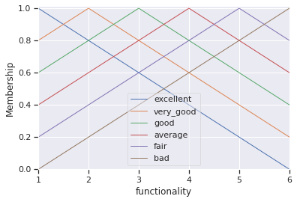

1. Modularity
   1. Very High (VH): 1/1.0+2/0.8+3/0.6+4/0.4+5/0.2+6/0.0
   2. High (H): 1/0.8+2/1.0+3/0.8+4/0.6+5/0.4+6/0.2
   3. Medium (M): 1/0.6+2/0.8+3/1.0+4/0.8+5/0.6+6/0.4
   4. Low (L): 1/0.4+2/0.6+3/0.8+4/1.0+5/0.8+6/0.6
   5. Very Low (VL): 1/0.2+2/0.4+3/0.6+4/0.8+5/1.0+6/0.8
   6. Nil (N): 1/0.0+2/0.2+3/0.4+4/0.6+5/0.8+6/1.0

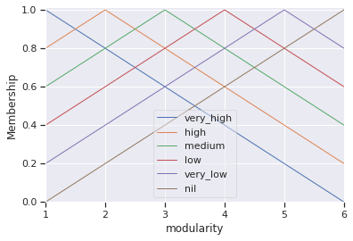

1. Design of User Interface
   1. Excellent (E): 1/1.0+2/0.8+3/0.6+4/0.4+5/0.2+6/0.0
   2. Very Good (VG): 1/0.8+2/1.0+3/0.8+4/0.6+5/0.4+6/0.2
   3. Good (G): 1/0.6+2/0.8+3/1.0+4/0.8+5/0.6+6/0.4
   4. Average (AV): 1/0.4+2/0.6+3/0.8+4/1.0+5/0.8+6/0.6
   5. Fair (F): 1/0.2+2/0.4+3/0.6+4/0.8+5/1.0+6/0.8
   6. Bad (B): 1/0.0+2/0.2+3/0.4+4/0.6+5/0.8+6/1.0

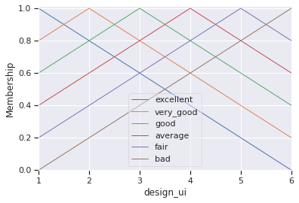

## Dataset (test cases) generation

Note: Some of the not-so-important code is omitted, to view the entire code, refer Appendix

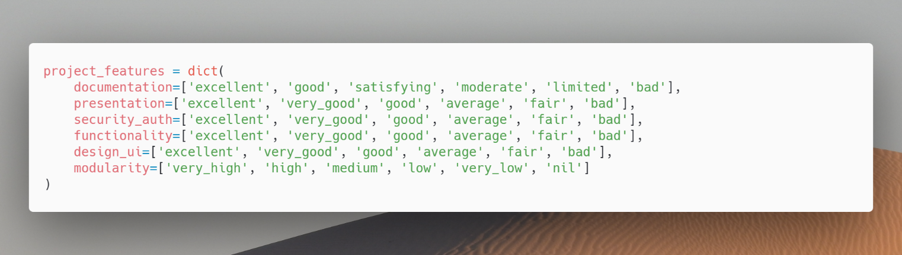We first define our project attributes, so that it can easily be referenced at later parts of our program

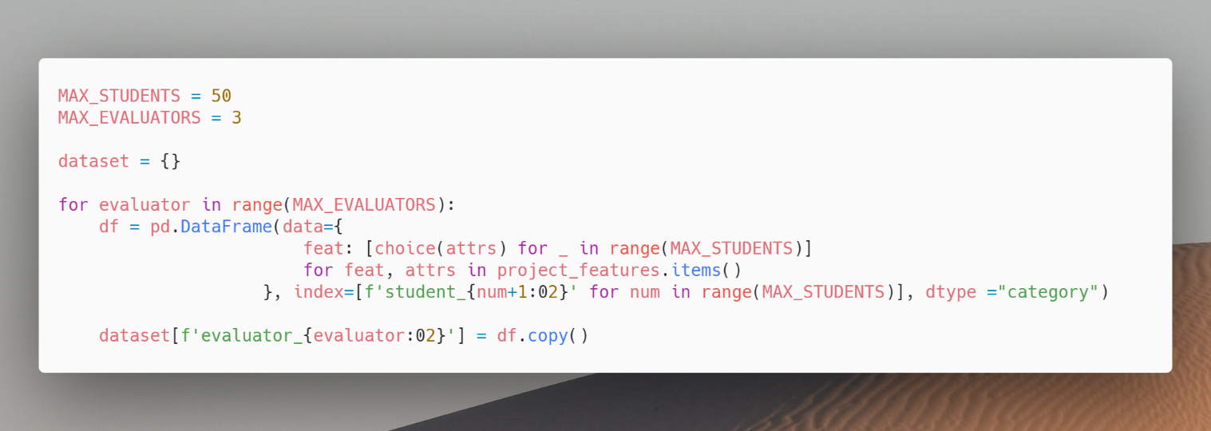

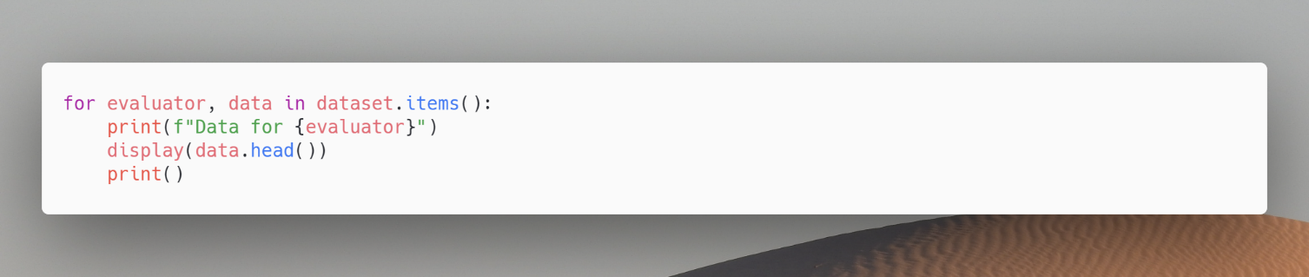Now we can print the dataset and visualize the table

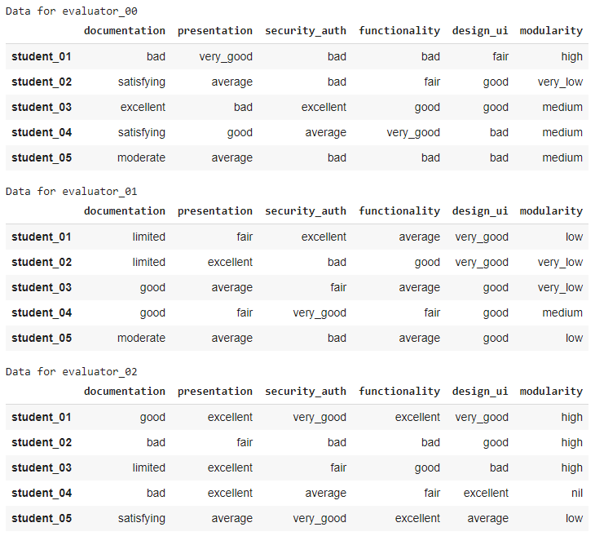

The above is the first 5 samples of each of the evaluators, in total we have 3 evaluators and 50 students, that is in total of 50 test case (each student = one test case).

## Fuzzy Logic System Creation

We’ll be using skfuzzy, an easy to use fuzzy logic library for python. Each of our attribute (document, design …) needs a fuzzy set with it, and for that we require a membership function, this membership function can be created using the fuzzy set values we defined earlier.

Following is a helper function that converts the fuzzy set values into 3 points that define a triangular membership function.

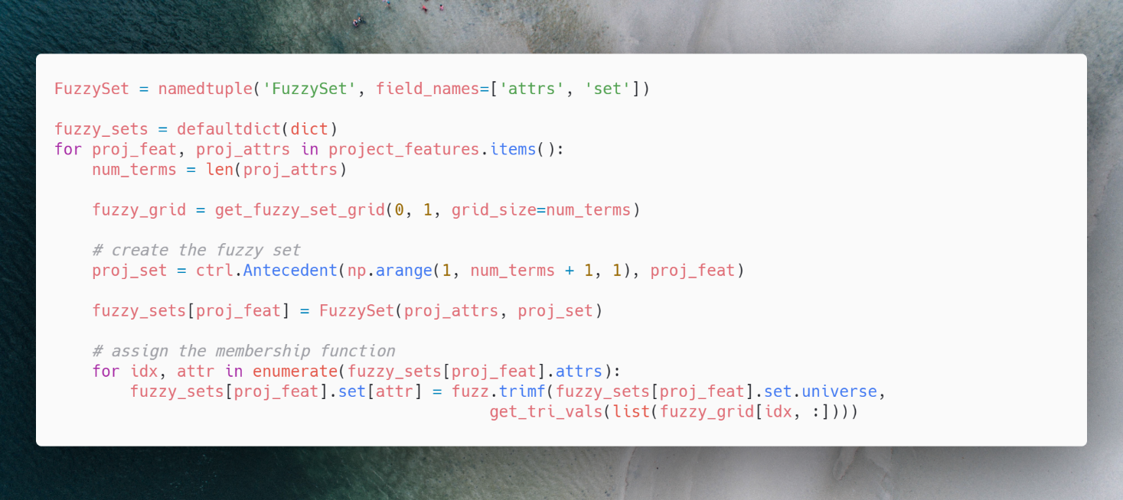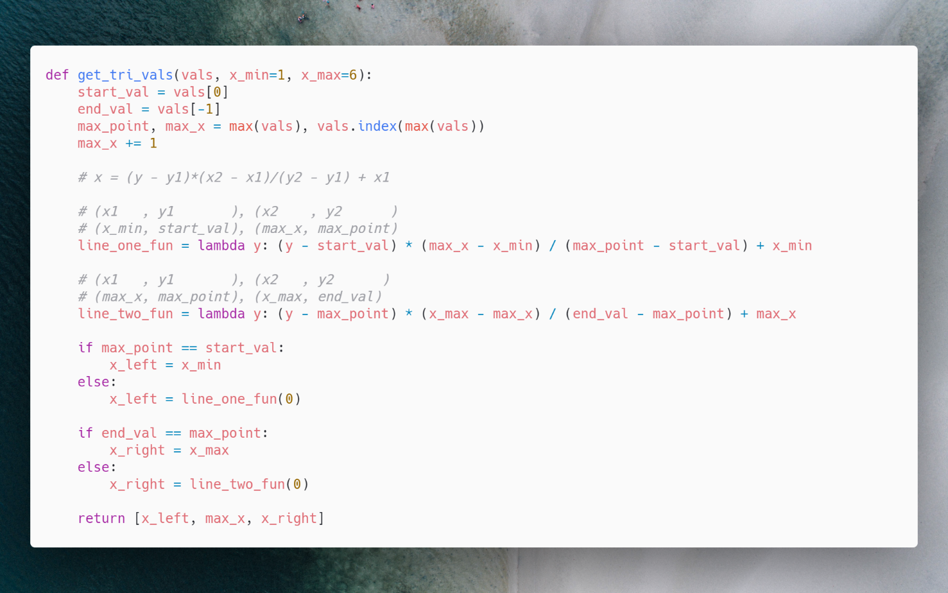

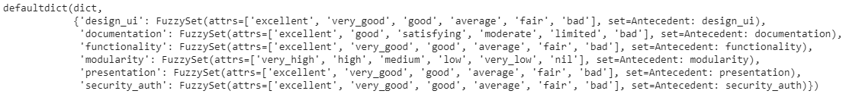

Also, we can view the membership functions,

|  |  |
| --- | --- |
|  |  |
|  |  |
|  |  |

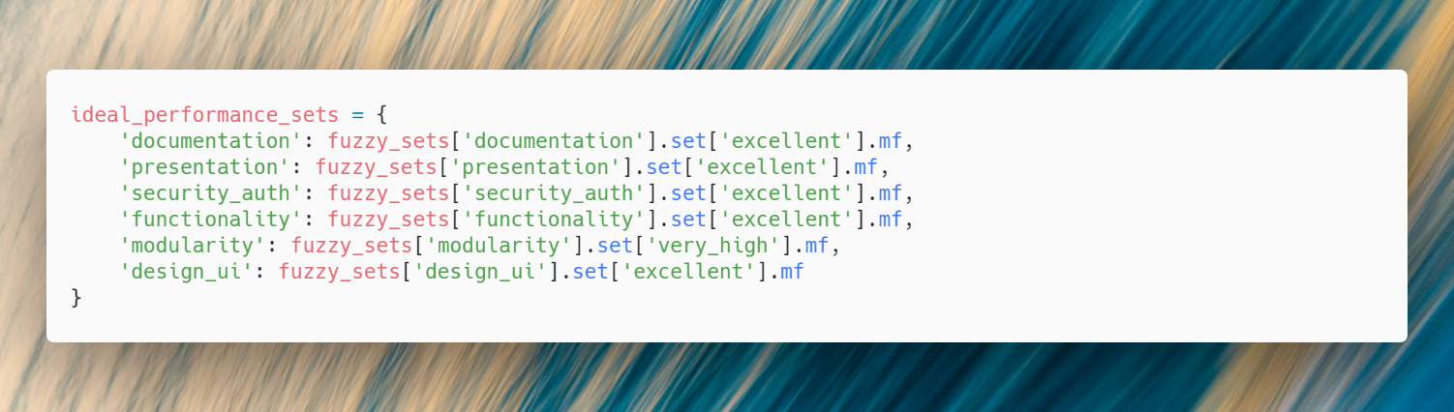Now we define the ideal performance of each of them,

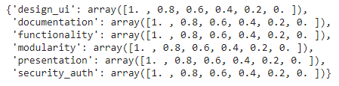

## Evaluating Student Performance

A panel of 3 evaluators are formed that evaluate each of the student performance based on our 6 criteria, these evaluators state their opinion linguistically, and an opinion matrix is formed based on that.

We can demonstrate how this happens, consider the following student, with evaluation for 6 criteria by 3 evaluators,

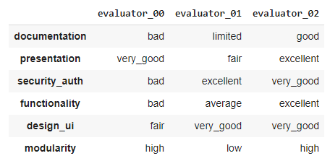

For each of the linguistic value, we get the membership value, and compare the distance from the “ideal” performance we defined before,

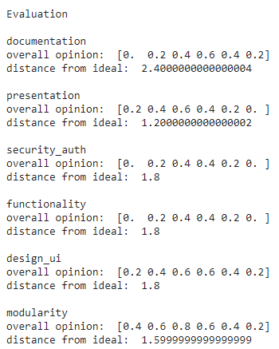

$$documentation= bad \bigwedge{limited}\bigwedge{good} \\ presentation=very good \bigwedge{fair}\bigwedge{excellent} \\ security auth=bad\bigwedge{excellent}\bigwedge{very good} \\ functionality=bad\bigwedge{average\bigwedge{excellent}} \\ design ui=fair\bigwedge{very good\bigwedge{very good}} \\ modularity=high \bigwedge{low \bigwedge{high}}$$

And the distance from ideal is calculated as,



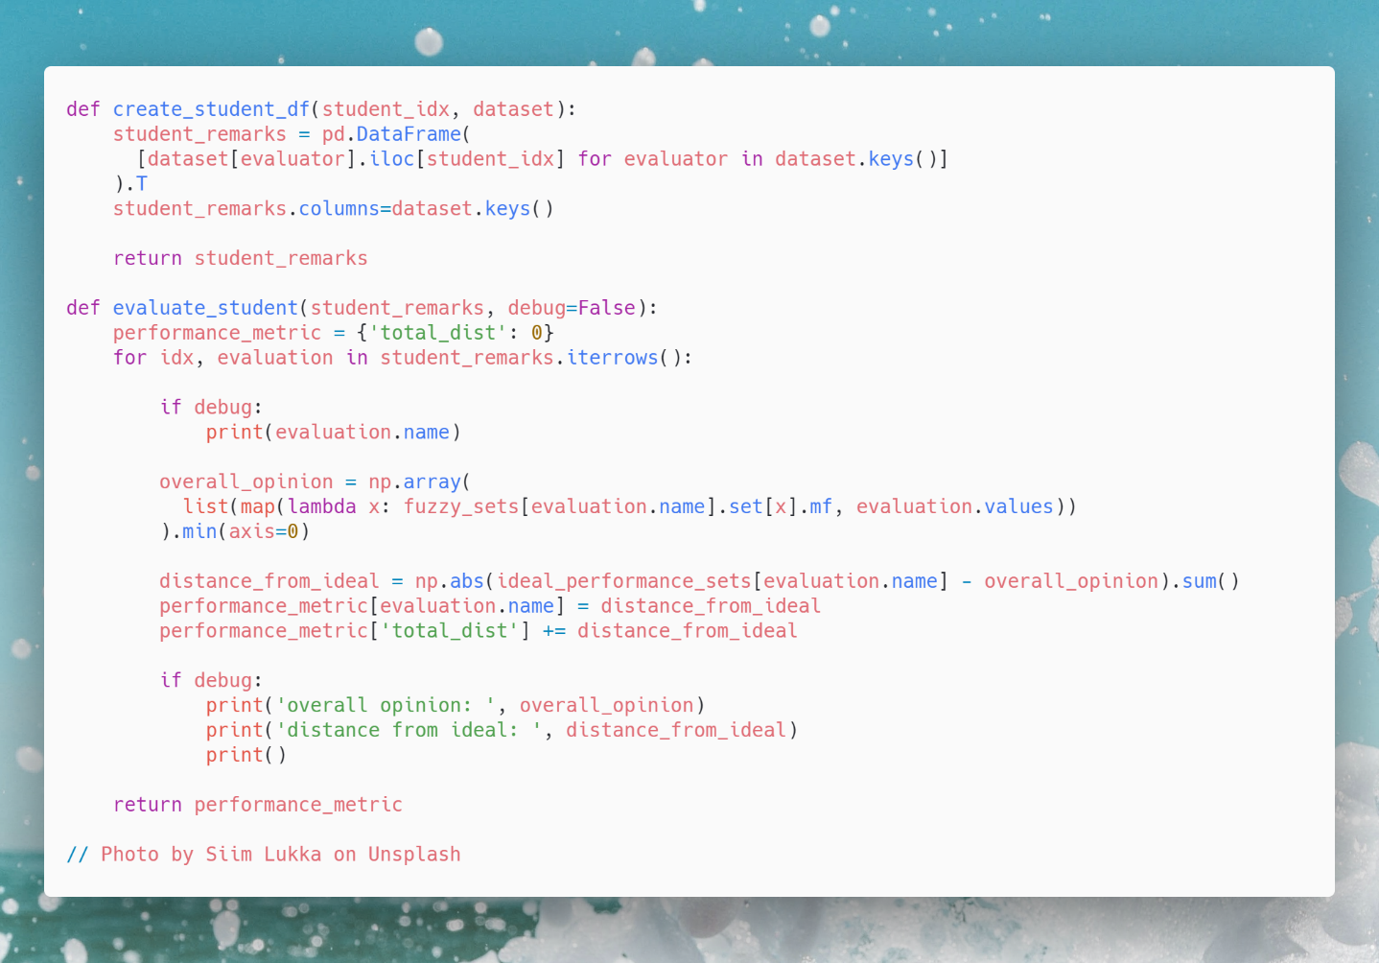Using this logic, we apply it on all of the students in the dataset,

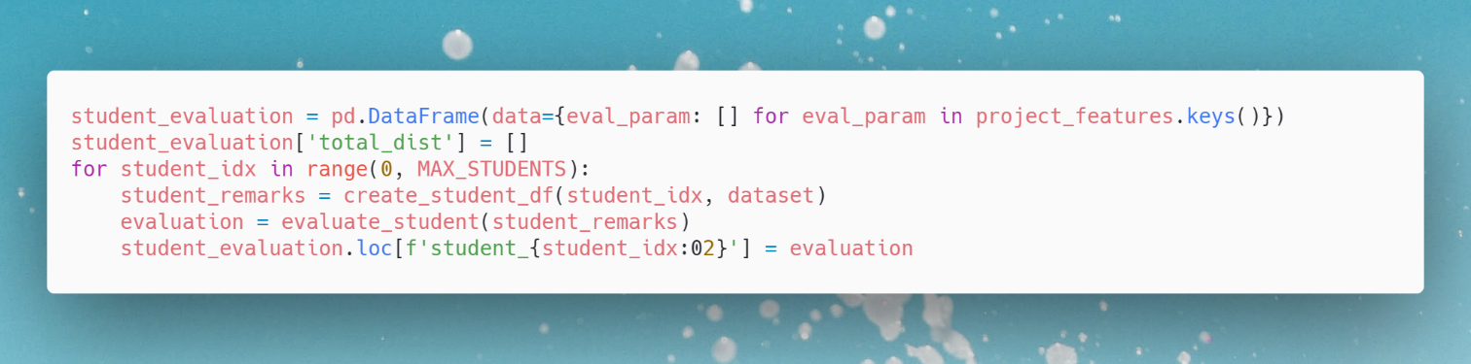

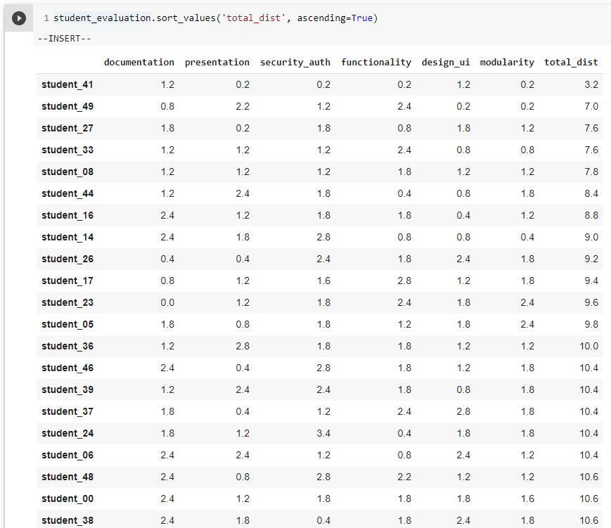

For grading we choose 6 grades,

* **Ex**: Equivalent to Excellent of Documentation, Presentation, Security, Functionality and User Interface and Very High of Modularity
* **A+**: Equivalent to Good of Documentation, Very Good of Presentation, Security, Functionality and User Interface, and High of Modularity
* **A**: Equivalent to Satisfying of Documentation, Good of Presentation, Security, Functionality and User Interface, and Medium of Modularity
* **B**: Equivalent of Moderate of Documentation, Average of Presentation, Security, Functionality and User Interface, and Low of Modularity
* **B+**: Equivalent of Limited of Documentation, Moderate of Presentation, Security, Functionality and User Interface, and Very Low of Modularity
* **C**: Equivalent of Bad of Documentation, Presentation, Security, Functionality and User Interface and Nil of Modularity

Now we compute the distance of Ex and other grades,

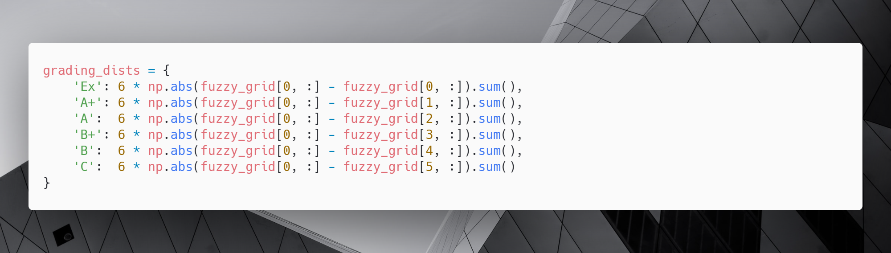

Here, the FuzzyGrid is as follows,

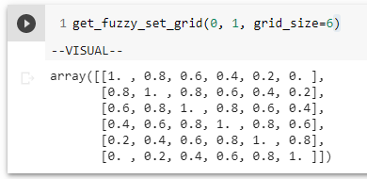

And the grading distance matrix is,

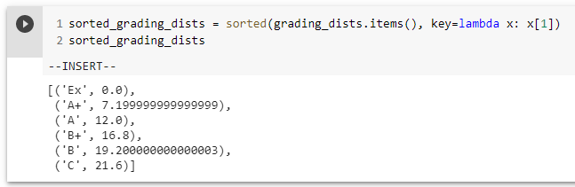

So,

IF total < 7.19 THEN grade = Ex

IF total >= 7.19 AND total < 12.00 THEN grade = A+

IF total >= 12.0 AND total < 16.80 THEN grade = A

IF total >= 16.80 AND total < 19.20 THEN grade = B+

IF total >= 19.20 AND total < 21.60 THEN grade = B

IF total >= 21.60 THEN grade = C

We can apply the above logic in our dataset as,

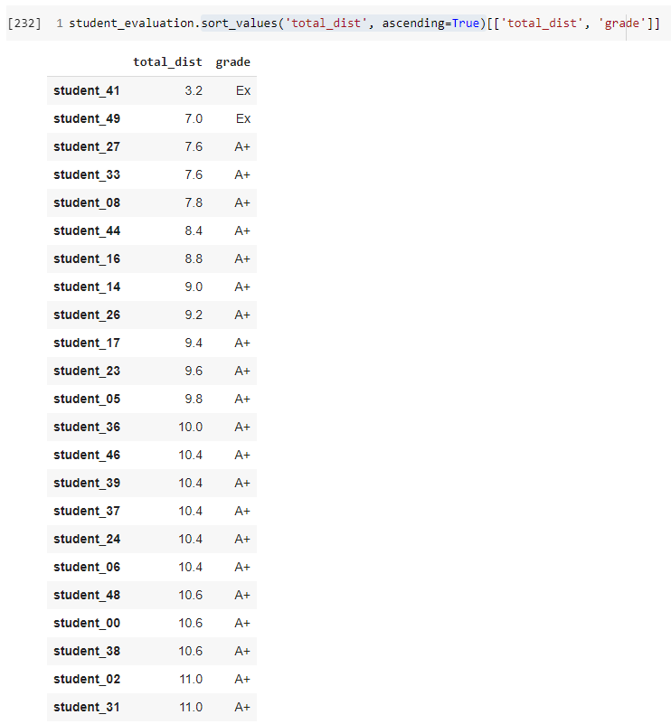

The above figure shows the total distance of the student from idea, and also the grade assigned to them based on the distance, lower the distance, higher the grade.

Refer to Results and Conclusion in this Assignment to see the grade of all the 50 students.

## Results

|  |  |  |  |  |  |  |  |  |
| --- | --- | --- | --- | --- | --- | --- | --- | --- |
|  | **document-**  **tation** | **present-ation** | **security-**  **auth** | **function-ality** | **design-**  **ui** | **modular-ity** | **total**  **dist** | **grade** |
| **student_41** | 1.2 | 0.2 | 0.2 | 0.2 | 1.2 | 0.2 | 3.2 | Ex |
| **student_49** | 0.8 | 2.2 | 1.2 | 2.4 | 0.2 | 0.2 | 7 | Ex |
| **student_27** | 1.8 | 0.2 | 1.8 | 0.8 | 1.8 | 1.2 | 7.6 | A+ |
| **student_33** | 1.2 | 1.2 | 1.2 | 2.4 | 0.8 | 0.8 | 7.6 | A+ |
| **student_08** | 1.2 | 1.2 | 1.2 | 1.8 | 1.2 | 1.2 | 7.8 | A+ |
| **student_44** | 1.2 | 2.4 | 1.8 | 0.4 | 0.8 | 1.8 | 8.4 | A+ |
| **student_16** | 2.4 | 1.2 | 1.8 | 1.8 | 0.4 | 1.2 | 8.8 | A+ |
| **student_14** | 2.4 | 1.8 | 2.8 | 0.8 | 0.8 | 0.4 | 9 | A+ |
| **student_26** | 0.4 | 0.4 | 2.4 | 1.8 | 2.4 | 1.8 | 9.2 | A+ |
| **student_17** | 0.8 | 1.2 | 1.6 | 2.8 | 1.2 | 1.8 | 9.4 | A+ |
| **student_23** | 0 | 1.2 | 1.8 | 2.4 | 1.8 | 2.4 | 9.6 | A+ |
| **student_05** | 1.8 | 0.8 | 1.8 | 1.2 | 1.8 | 2.4 | 9.8 | A+ |
| **student_36** | 1.2 | 2.8 | 1.8 | 1.8 | 1.2 | 1.2 | 10 | A+ |
| **student_46** | 2.4 | 0.4 | 2.8 | 1.8 | 1.2 | 1.8 | 10.4 | A+ |
| **student_39** | 1.2 | 2.4 | 2.4 | 1.8 | 0.8 | 1.8 | 10.4 | A+ |
| **student_37** | 1.8 | 0.4 | 1.2 | 2.4 | 2.8 | 1.8 | 10.4 | A+ |
| **student_24** | 1.8 | 1.2 | 3.4 | 0.4 | 1.8 | 1.8 | 10.4 | A+ |
| **student_06** | 2.4 | 2.4 | 1.2 | 0.8 | 2.4 | 1.2 | 10.4 | A+ |
| **student_48** | 2.4 | 0.8 | 2.8 | 2.2 | 1.2 | 1.2 | 10.6 | A+ |
| **student_00** | 2.4 | 1.2 | 1.8 | 1.8 | 1.8 | 1.6 | 10.6 | A+ |
| **student_38** | 2.4 | 1.8 | 0.4 | 1.8 | 2.4 | 1.8 | 10.6 | A+ |
| **student_02** | 1.2 | 1.8 | 1.2 | 2.2 | 2.8 | 1.8 | 11 | A+ |
| **student_31** | 3.2 | 0.4 | 2.4 | 1.8 | 0.8 | 2.4 | 11 | A+ |
| **student_42** | 1.8 | 1.2 | 2.4 | 2.8 | 2.4 | 0.4 | 11 | A+ |
| **student_11** | 2.2 | 2.8 | 0.4 | 2.4 | 0.8 | 2.4 | 11 | A+ |
| **student_35** | 1.8 | 2.8 | 1.2 | 1.2 | 0.8 | 3.4 | 11.2 | A+ |
| **student_19** | 0.4 | 1.8 | 1.6 | 3.4 | 1.8 | 2.4 | 11.4 | A+ |
| **student_34** | 3.2 | 1.2 | 0.2 | 1.2 | 2.4 | 3.2 | 11.4 | A+ |
| **student_13** | 1.6 | 0.8 | 2.4 | 1.8 | 1.6 | 3.2 | 11.4 | A+ |
| **student_03** | 2.4 | 1.2 | 1.6 | 1.8 | 1.8 | 2.8 | 11.6 | A+ |
| **student_10** | 1.2 | 1.8 | 2.4 | 1.8 | 2.4 | 2.4 | 12 | A |
| **student_12** | 2.4 | 2.4 | 1.8 | 1.8 | 1.8 | 1.8 | 12 | A |
| **student_28** | 0.2 | 2.8 | 2.4 | 2.4 | 1.8 | 2.4 | 12 | A |
| **student_45** | 2.4 | 3.4 | 2.4 | 1.2 | 1.8 | 0.8 | 12 | A |
| **student_21** | 1.8 | 2.8 | 1.8 | 1.8 | 0.8 | 3.2 | 12.2 | A |
| **student_29** | 1.2 | 2.8 | 1.8 | 0.8 | 2.8 | 2.8 | 12.2 | A |
| **student_07** | 1.2 | 2.8 | 1.2 | 2.8 | 1.8 | 2.4 | 12.2 | A |
| **student_30** | 1.8 | 2.4 | 3.2 | 3.4 | 1.2 | 0.4 | 12.4 | A |
| **student_20** | 1.2 | 1.2 | 3.2 | 1.2 | 2.4 | 3.2 | 12.4 | A |
| **student_22** | 0.4 | 1.8 | 2.4 | 1.8 | 3.2 | 2.8 | 12.4 | A |
| **student_40** | 3.2 | 1.2 | 1.2 | 1.8 | 2.4 | 2.8 | 12.6 | A |
| **student_09** | 3.4 | 1.8 | 2.4 | 3.2 | 1.2 | 0.8 | 12.8 | A |
| **student_15** | 2.4 | 2.2 | 2.8 | 0.8 | 1.8 | 2.8 | 12.8 | A |
| **student_32** | 1.8 | 3.4 | 1.6 | 2.4 | 3.4 | 0.4 | 13 | A |
| **student_01** | 2.8 | 1.2 | 3.6 | 2.8 | 1.2 | 1.8 | 13.4 | A |
| **student_43** | 0.2 | 2.4 | 2.8 | 3.4 | 2.2 | 2.4 | 13.4 | A |
| **student_18** | 2.8 | 2.8 | 1.8 | 1.8 | 2.4 | 1.8 | 13.4 | A |
| **student_04** | 2.2 | 2.8 | 2.4 | 1.8 | 2.8 | 2.2 | 14.2 | A |
| **student_47** | 3.4 | 1.8 | 2.4 | 2.4 | 1.8 | 3.4 | 15.2 | A |
| **student_25** | 3.6 | 2.4 | 2.4 | 1.8 | 2 | 3.4 | 15.6 | A |

# Bibliography

1. Pandey, M., Srivastava, P.K. and Bhattacharjee, V., 2015. Fuzzy logic based grading system for student projects using quality attributes. International Journal of Engineering and Technology, 7, pp.1304-1308.
2. https://github.com/scikit-fuzzy/scikit-fuzzy

# Appendix